**Software Used in this Lab**

In this lab, you will use [MySQL](https://www.mysql.com/?utm_medium=Exinfluencer&utm_source=Exinfluencer&utm_content=000026UJ&utm_term=10006555&utm_id=NA-SkillsNetwork-Channel-SkillsNetworkCoursesIBMDB0110ENSkillsNetwork24601058-2021-01-01). MySQL is a Relational Database Management System (RDBMS) designed to efficiently store, manipulate, and retrieve data.

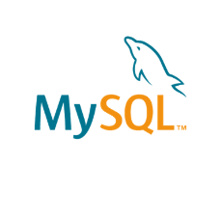

To complete this lab you will utilize MySQL relational database service available as part of IBM Skills Network Labs (SN Labs) Cloud IDE. SN Labs is a virtual lab environment used in this course.

**Database Used in this Lab**

The database used in this lab is an internal database. You will be working on a sample HR database. This HR database schema consists of 5 tables called **EMPLOYEES**, **JOB_HISTORY**, **JOBS**, **DEPARTMENTS** and **LOCATIONS**. Each table has a few rows of sample data. The following diagram shows the tables for the HR database:

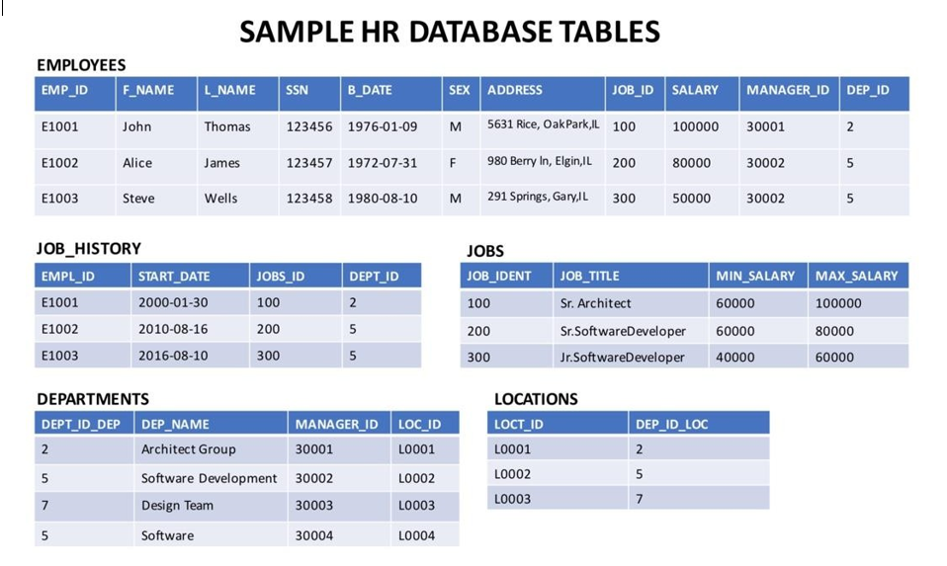

**Objectives**

After completing this lab, you will be able to use phpMyAdmin with MySQL to:

* Create a database.
* Create tables using SQL scripts
* Load data into tables

**Exercise**

In this exercise through different tasks, you will learn how to create tables and load data in the MySQL database service using the phpMyAdmin graphical user interface (GUI) tool.

**Task A: Create a database**

1. Click on **Skills Network Toolbox**. In **Database** section, click **MySQL**.

To start the MySQL click **Start**.

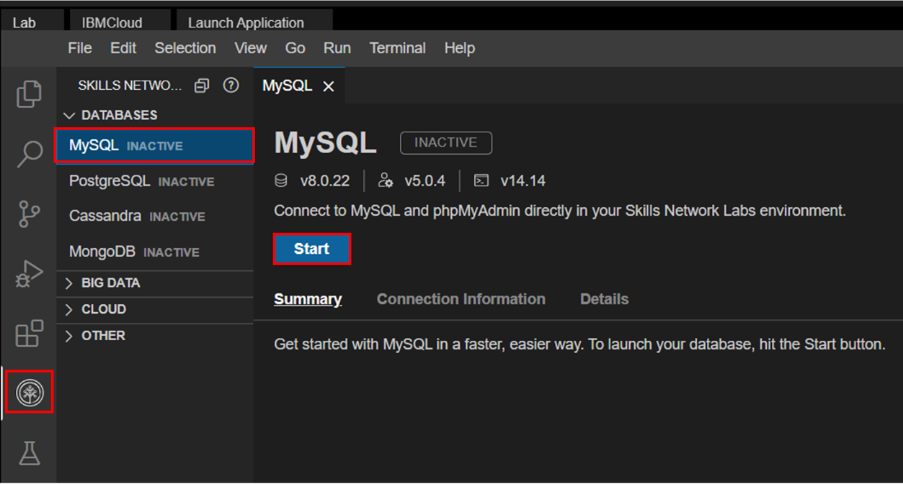

1. Once **MySQL** has started, click on **phpMyAdmin button** to open **phpMyAdmin** in the same window.

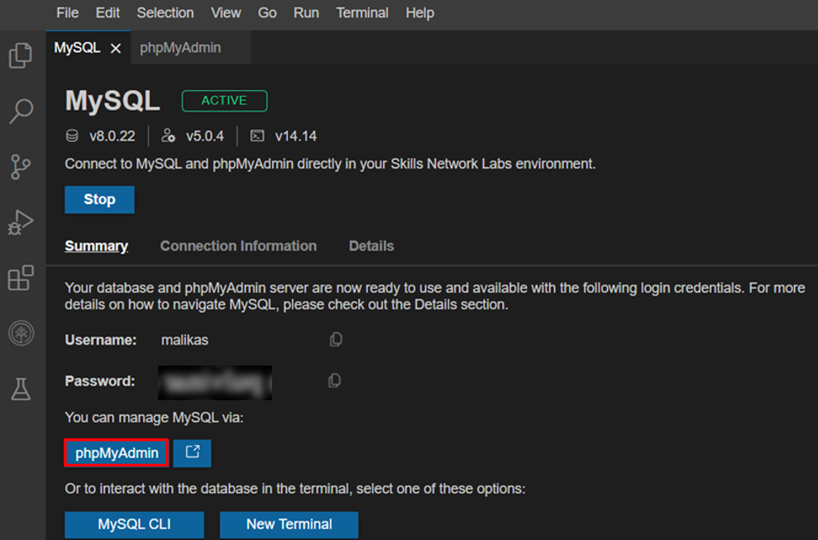

1. You will see the phpMyAdmin GUI tool.

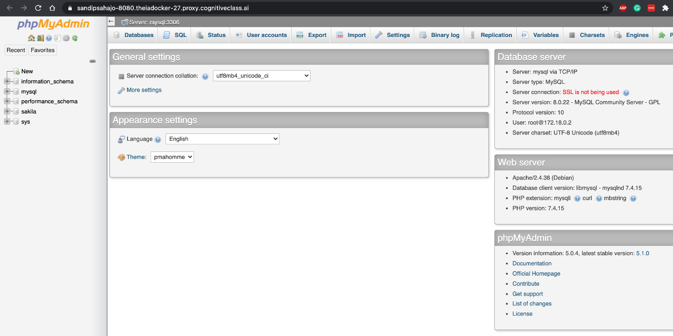

1. In the tree-view, click **New** to create a new empty database. Then enter **HR** as the name of the database and click **Create**.

The encoding will be left as **utf8mb4_0900_ai_ci**. UTF-8 is the most commonly used character encoding for content or data.

Proceed to Task B.

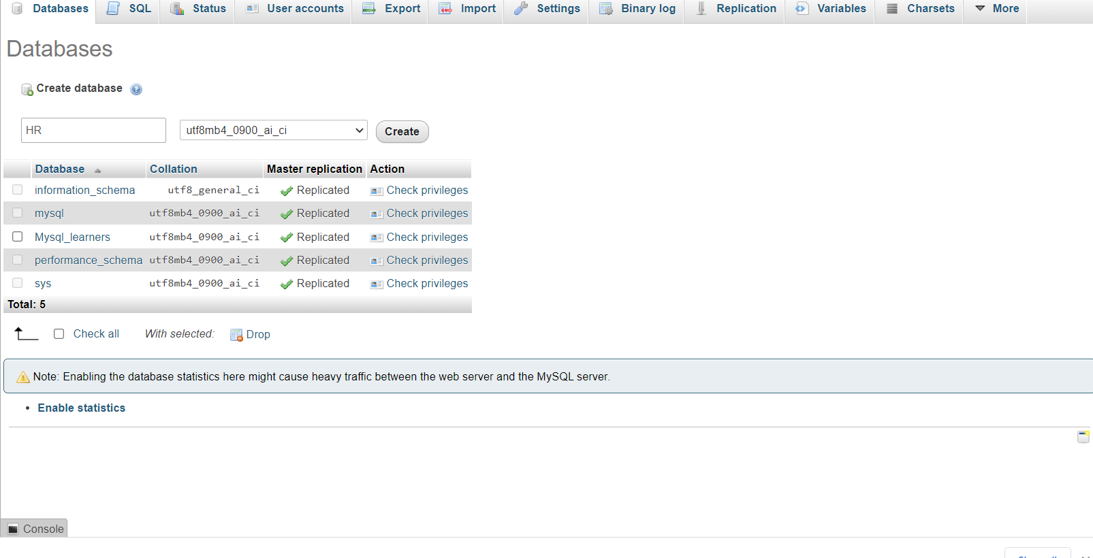

**Exercise 1: Create tables using SQL scripts**

In this exercise, you will learn how to execute a script containing the CREATE TABLE commands for all the tables rather than create each table manually by typing the DDL commands in the SQL editor.

1. Download the script file to your computer:
   * [HR_Database_Create_Tables_Script.sql](https://cf-courses-data.s3.us.cloud-object-storage.appdomain.cloud/IBMDeveloperSkillsNetwork-DB0201EN-SkillsNetwork/labs/MySQL/week2/HR_Database_Create_Tables_Script.sql)

* Select the HR database. Later click on the Import tab.
* Click on **choose file**. Browse for the file and upload it .
* Later scroll down and click on **Go**.

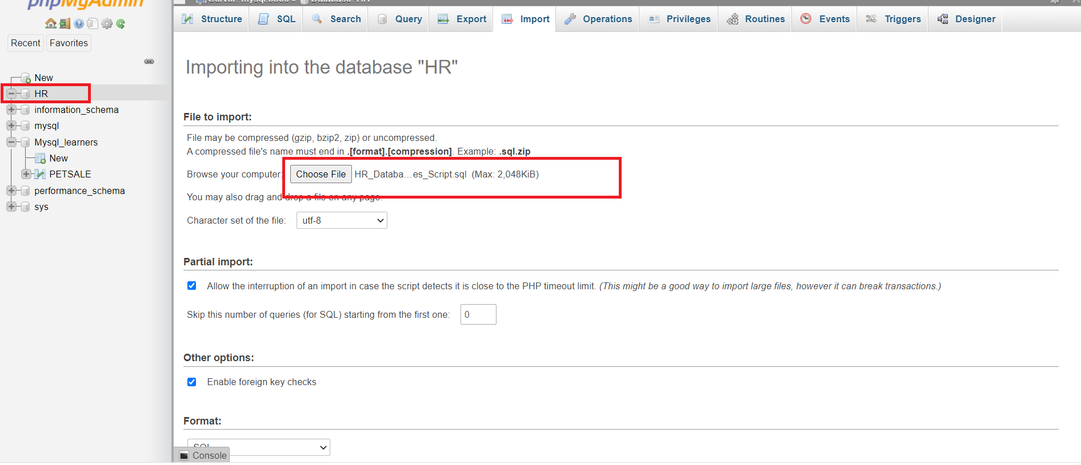

* The script then gets imported successfully.

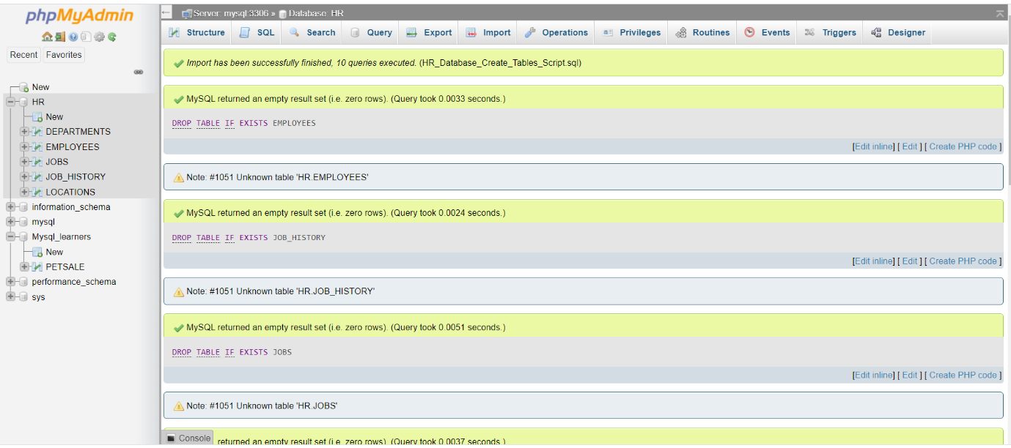

* Click on any of the tables and you will see its Table Definition (that is, its list of columns, data types, etc).

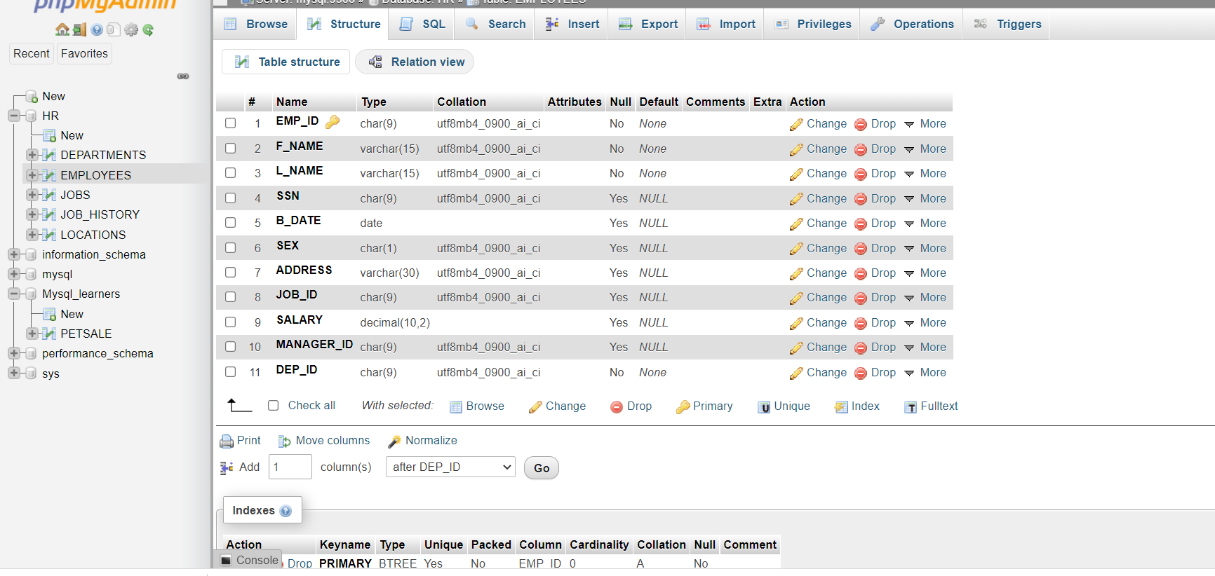

**Exercise 2: Load data into tables**

In this exercise, you will learn how data can be loaded into MySQL. You could manually insert each row into the table one by one, but that would take a long time. Instead, MySQL (and almost every other database) allows you to load data from .CSV files.

The steps below explain the process of loading data into the tables you created earlier in exercise 1.

1. Download the 5 .csv files below to your local computer:
   * [Departments.csv](https://cf-courses-data.s3.us.cloud-object-storage.appdomain.cloud/IBMDeveloperSkillsNetwork-DB0201EN-SkillsNetwork/labs/Labs_Coursera_V5/datasets/HR_Database/Departments.csv)
   * [Employees.csv](https://cf-courses-data.s3.us.cloud-object-storage.appdomain.cloud/IBMDeveloperSkillsNetwork-DB0201EN-SkillsNetwork/labs/MySQL/week2/data/Employees_updated.csv)
   * [Jobs.csv](https://cf-courses-data.s3.us.cloud-object-storage.appdomain.cloud/IBMDeveloperSkillsNetwork-DB0201EN-SkillsNetwork/labs/Labs_Coursera_V5/datasets/HR_Database/Jobs.csv)
   * [Locations.csv](https://cf-courses-data.s3.us.cloud-object-storage.appdomain.cloud/IBMDeveloperSkillsNetwork-DB0201EN-SkillsNetwork/labs/Labs_Coursera_V5/datasets/HR_Database/Locations.csv)
   * [JobsHistory.csv](https://cf-courses-data.s3.us.cloud-object-storage.appdomain.cloud/IBMDeveloperSkillsNetwork-DB0201EN-SkillsNetwork/labs/MySQL/week2/data/JobsHistory.csv)

To load each table do the following steps.

* Select each table .
* Click on Import tab.
* Select the **csv** file and click on **Go** to load the csv file.

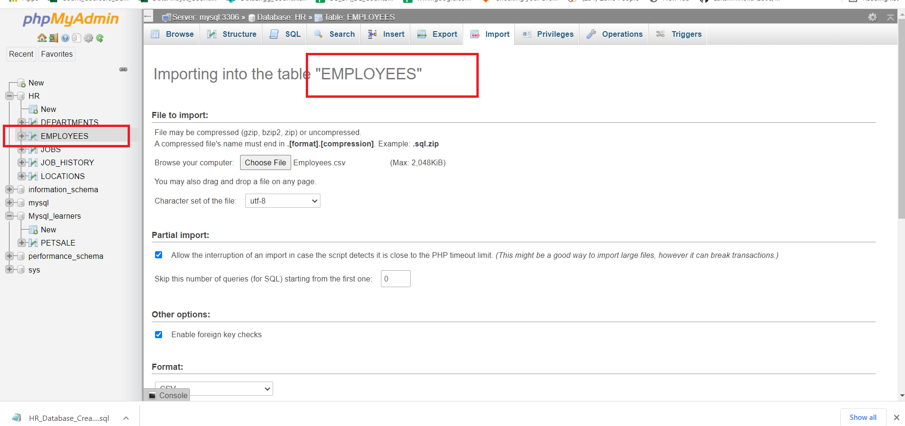

Once the tables are loaded , you will get a message that the records are inserted successfully.

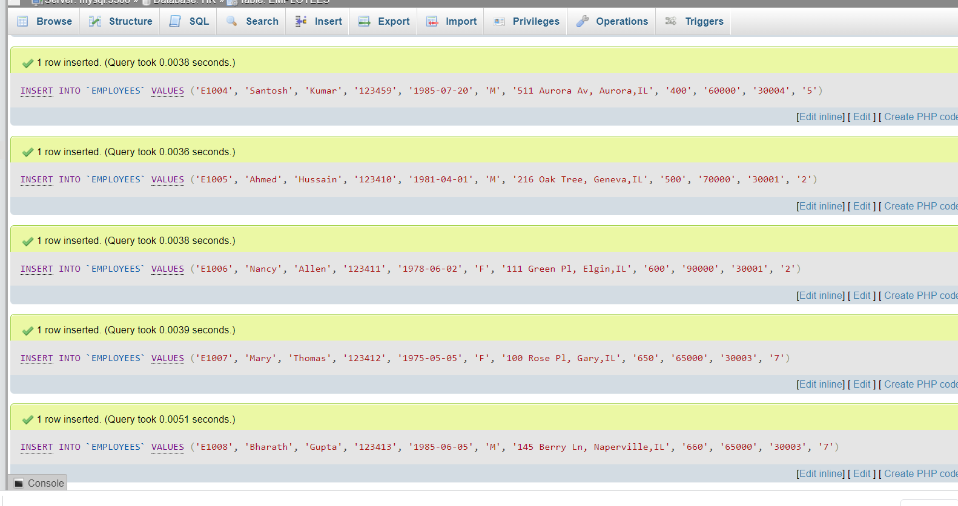

Further you can click on browse and view the data of each table.

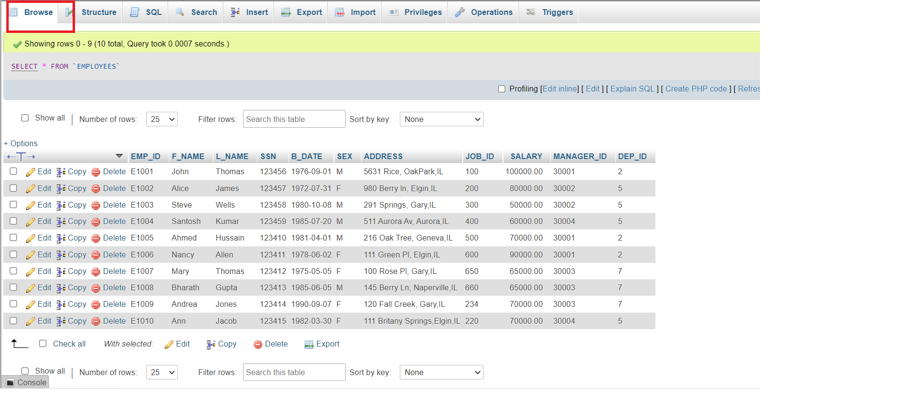

**Congratulations! You have completed this lab, and you are ready for the next topic.**

**Author(s)**

[Lakshmi Holla](https://www.linkedin.com/in/lakshmi-holla-b39062149/)

[Malika Singla](https://www.linkedin.com/in/malika-goyal-04798622/)

**Changelog**

| **Date** | **Version** | **Changed by** | **Change Description** |
| --- | --- | --- | --- |
| 2023-05-11 | 0.8 | Eric Hao & Vladislav Boyko | Updated Page Frames |
| 2023-05-10 | 0.7 | Eric Hao & Vladislav Boyko | Updated Page Frames |
| 2023-05-10 | 0.6 | Eric Hao & Vladislav Boyko | Updated Page Frames |
| 2023-05-05 | 0.5 | Benny Li | Updated and Re-Published |
| 2022-08-03 | 0.4 | Sathya Priya | Updated CSV Links |
| 2022-07-27 | 0.3 | Lakshmi Holla | Updated HTML tag |
| 2022-04-07 | 0.2 | Malika Singla | Updated screenshot |
| 2021-11-01 | 0.1 | Lakshmi Holla, Malika Singla | Initial Version |

**© IBM Corporation 2023. All rights reserved.**